***Hyperparameter Tuning***

***Parameters vs Hyperparameter Tuning***

Parameter are the internal variables of a model that are learned from data during the training process.

They define the model’s representation of the underlying patterns in the data.

For Example:

1. In a Linear Regression Model, the parameters the coefficients of the predictors.
2. In a neural network, the parameters are the weights and biases of the nodes.
3. In a decision tree, the parameters are the split point and split criteria at each node.

*Hyperparameters*

In machine learning, hyperparameters are parameters whose values are set before the learning process begins.

These parameters are not learned from the data and must be predefined.

They help in controlling the learning process and can significantly influence the performance of the model.

* In neural network, hyperparameters might include the learning rate, the number of layers in the network, or the number of nodes in each layer.
* In a support vector machine, the regularization parameter C or the kernel type can be considered as hyperparameters.
* In Decision tree, the maximum depth of a tree is Hyperparameter.

The best values for hyperparameters often cannot be determined in advance, and must be found through trial and error.

Parameter jo hota hai uska value during training set hota hai

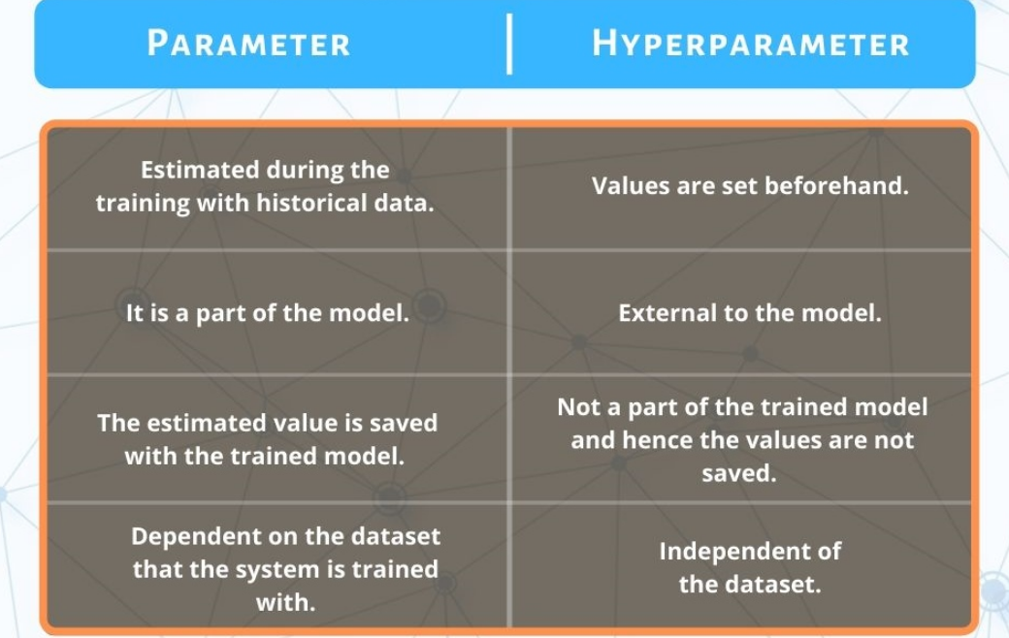

***Why Word Hyper?***

The choice of the word is primarily a naming convention to differentiate between 2 Type of values (Internal parameters & Guiding parameters) that influence the behaviour of a machine learning model. It’s also a root to the fact that the role they play is a meta one, in the sense that they control the structural aspect of learning process itself rather than being part of direct pattern-finding mission of the model.

Hyperparameter Training

1. GridSearch CV
2. Randomized SearchCV
3. Advance Techniques ( Will Learn jbh Hum Tree Based Algorithms karenge )

***GridSearchCV***

*GridSearchCV refers to an algorithm that performs an exhaustive search over a specifief grid of hyper parameters. Using cross validation to determine which hyperparameter combination gives the best Model Performance.*

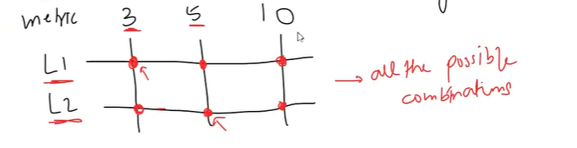

***Sequentially har combination pe***

*Model ko train krrha hai & not only that we also Apply Cross Validation with it.*

***E.g***

***m1, m2,m3,m4 ,m5,m6***

*ismese jo best Result deta hai*

***Vo vale Model ki Setting basically hum use krte hai For Setting up the Hyper parameters***

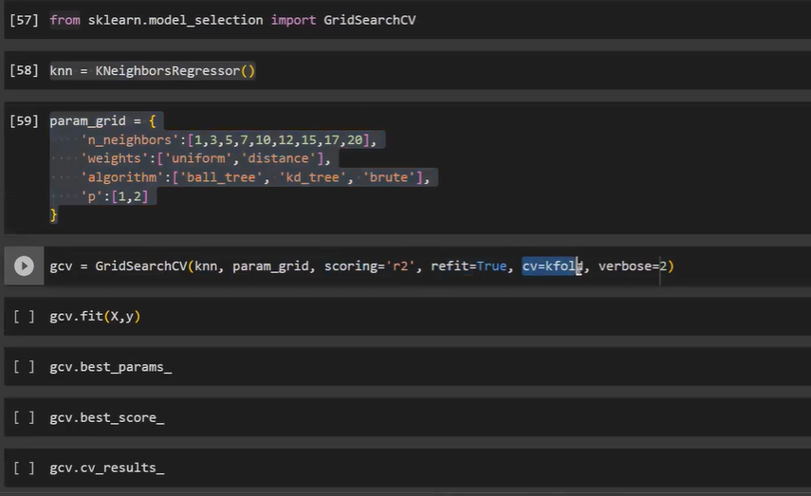

***Refit mtlb ki once we are done with all combination & humme best cpombination millgaya so hum firse 1 baar ML algo ko train krte hai ki Firse hum use karpaaye ushe***

*Randomized CV*

Disadvantage GridCV ka hai ki ushe bhaut time chaye hota hai

*Yeah Randomized CV solve krdeta hai*

Entire parameter usmese 1 Number Decide krte hai Hum & vo jo number decide kiya hai utna randomly 10 koibhi Try out karleta hai

Advantage:

Computation

Disadvantage:

Very High chance ki best vale pe poche hie na

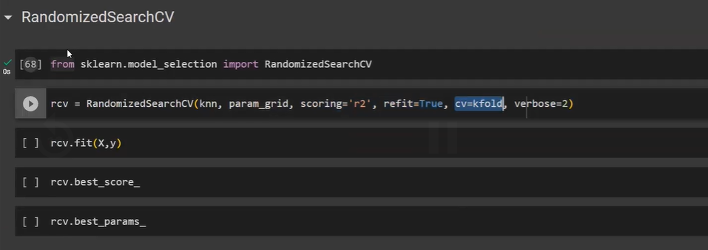

*Can this be improved?*

*Advance Technique*

*Advance Technique kaisi hoti hai ?*

*Understanding keliye zyaada difficult hai*

*It is a very different branch of mathematics.*

*Bayesian Optimization or Bayesian Search*

*This is the technique we use to findout the Best parameter combination without going through all parameters.*

*Python Libraries to do this :*

1. *Scikit-Op -> skopt*
2. *Optuna*
3. *Hyperopt*

Saari library ka kaam yeahi hai ki Best vale pe pochna hai